|  |  |
| --- | --- |
| **OO Analysis and Design - Final Project** | **SDH2-A**  **Laiba Asif (R00201303)**  **Shaun Milanzi (R00)**  **30/04/2023** |

Use Case Diagram

Domain Model

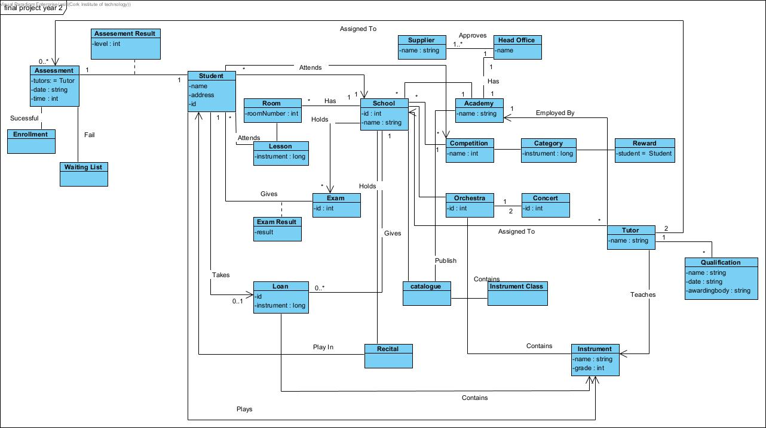

Class Diagram

Minutes of Meetings

MEETING1

Location: Library

Date: /04/2023

Start Time: 14:30

Finish Time: 15:30

Attendees:

Activity Description:

* Discussed what was required to complete the project
* Discussed the different diagrams needed to complete the project
* Agreed to read up and watch videos on things we weren’t sure of how to do in our own time for our next meeting
* Kept a record of what was done to include in our log